## Current Activities

Hursley site finally reopened last week. No mandatory masks or social distancing, but they have made available badge lanyards in red, yellow and green – from keep away to come closer! There has not been a mad rush back to office desks, and we curators are also taking things slowly. We do have a lot of tidying up to do; lots of donations have been piled up in our absence, which all need sorting out. We are expecting a shipment of four boxes of manuals from St. Andrews University shortly, mainly going back to their IBM S/360 model 44 (developed in Hursley) and 1620 systems.

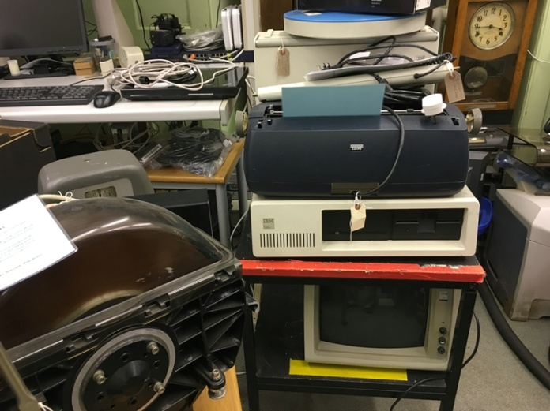 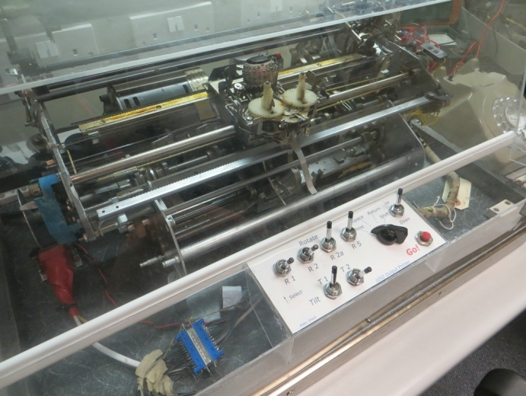

Hardware everywhere 1052 golf ball console printer

Our first venture into the museum last week saw some checks on hardware that was working OK 2 years ago. Our 029 card punch was a bit sluggish, increased friction causing the main drive belt to slip (it has stretched and needs replacing, but we can’t get one anywhere) but once the friction clutch warmed up it began to behave itself. The 1052 golf ball printer is also not too happy and is also hesitating – a job for another day. We also started sorting through hardware where we have more than two examples, and moving the excess into a ‘for disposal’ area to create more space for new and unique donations. Another job, partially completed, is to catch up on photographs of hardware that was catalogued 2 years ago but we were excluded before photos could be processed.

We now have a date for shipping our 080 card sorter to Bletchley Park – 22nd March. We have ordered a new toughened glass lid from a local supplier to replace the one broken during transit from Oslo. Our own small stock of these glass panels are from a different model sorter, perhaps a 101 statistical sorter, which fit correctly width-wise but are too deep and protrude out the front, preventing the lid from closing.

We are also thinking about a complementary display in the museum to reflect the Bletchley exhibition. This will probably include our tabulator and our second 077 collator. These would be complemented by photographs and text panels telling the largely unknown story of the data processing operation behind the code breaking.

Our [museum YouTube channel](https://www.youtube.com/channel/UCX00VSgR9Ul9pvayqc5loqA/videos) is proving to be very popular, particularly the video of our 1052 in slo-mo with 2.1 million views!